The “Pandemic” of 1918-–and the Viral Theory

I hear it all the time. From Physicians, “How can you say viruses don’t exist? I treat people with viral illness all the time.” Or from patients, “My whole family got really sick—so there must be viruses!”
Let’s be clear. There is disease, as in “Dis-Ease”. People get sick and some die of the sickness. And I can admit to the ability of harvesting tissue from one animal and injecting it into another species and causing disease-- as Judy Mikovits describes it—“infection by injection”. But that does not prove the existence of invisible, sub-microscopic unicorns that fly from one person’s nose to another as the CAUSE of that disease. It is the unproven notion of airborne viral illness that has enslaved humanity to the corrupt medical cartel. What better psychological wedge can be implemented against humanity than making people afraid of invisible emanations from other people?
There are multiple lines of evidence to dispute the classic viral disease paradigm, including historical records, biological evidence (or lack thereof) and clinical “experiments”. In this article I will discuss the largest clinical case study of all time—the 1918 worldwide influenza outbreak.
It may come as a surprise to most people—even doctors-- that person-to-person transmission of influenza has not been proven. In fact, during the COVID scare in the summer of 2020, the CDC itself published research in the journal of Emerging Infectious Diseases that showed neither wearing gloves, wearing a mask, nor disinfecting the surfaces you touch stops community spread of Influenza. “Influenza” is Italian for “influence” and does not imply an organism or spread between people. Current professional literature after 2005 will make grandiose assertions. But assertions are not evidence, even if you say it over and over as in this case. A Science review article from 2021states, “However, there is robust evidence supporting the airborne transmission of many respiratory viruses, including severe acute respiratory syndrome coronavirus (SARS-CoV), …” [1] And just in case you didn’t believe it the first time, they repeat later in the article, “Despite the assumed dominance of droplet transmission, there is robust evidence supporting the airborne transmission of many respiratory viruses, including measles virus…” The problem is the evidence is not all that “robust”. Bioinformatics and genetic fragments do not prove disease causation. The question of causation was seriously studied during the outbreak of disease at the time of WWI.
Today, in the age of COVID, we have learned to question the official death numbers because they just don’t correspond to our observations. And we observed the ease with which “cause of death” can be skewed by hospitals coding for profit and propaganda (remember the motorcyclist who crashed and died of COVID?). Similarly, the story of the great and awful 1918 pandemic has changed over time, and one should not take modern “retelling” at face value. Kate Daly, a former Fox newscaster and current radio show host researched news archives about the 1918 Pandemic, and discovered that like a giant whispering game, over the last century, the numbers of the dead reported in newspapers consistently rose. Original reports of dead are very small in the US county by county adding up to about 100,000. But by 1920, they were reporting 500,000 dead in the US. In 1941 two decades after the event, they claimed an estimate of 10 million dead worldwide. By 1975 newspaper reports doubled the count to 20 million dead. Mike Leavitt DHS reported in 2005 the number to be 38 million, and now the CDC tells us 50 million died worldwide.[2]
As I took up the news archive search, I very quickly recognized that newspapers of the early 20th Century were used for the same propaganda we suffer today. We may think that only news in the digital age is controlled by a few major corporate voices, but I found, from 1917-1922, papers from all over America had identical articles under different banners. It is somewhat humorous, but also confirmatory of the controlled nature of the press that, in the days of linotype, when each story was hand produced using lead printing letters, spelling errors were different, but the exact verbiage was used in “small town newspapers” all over the country.

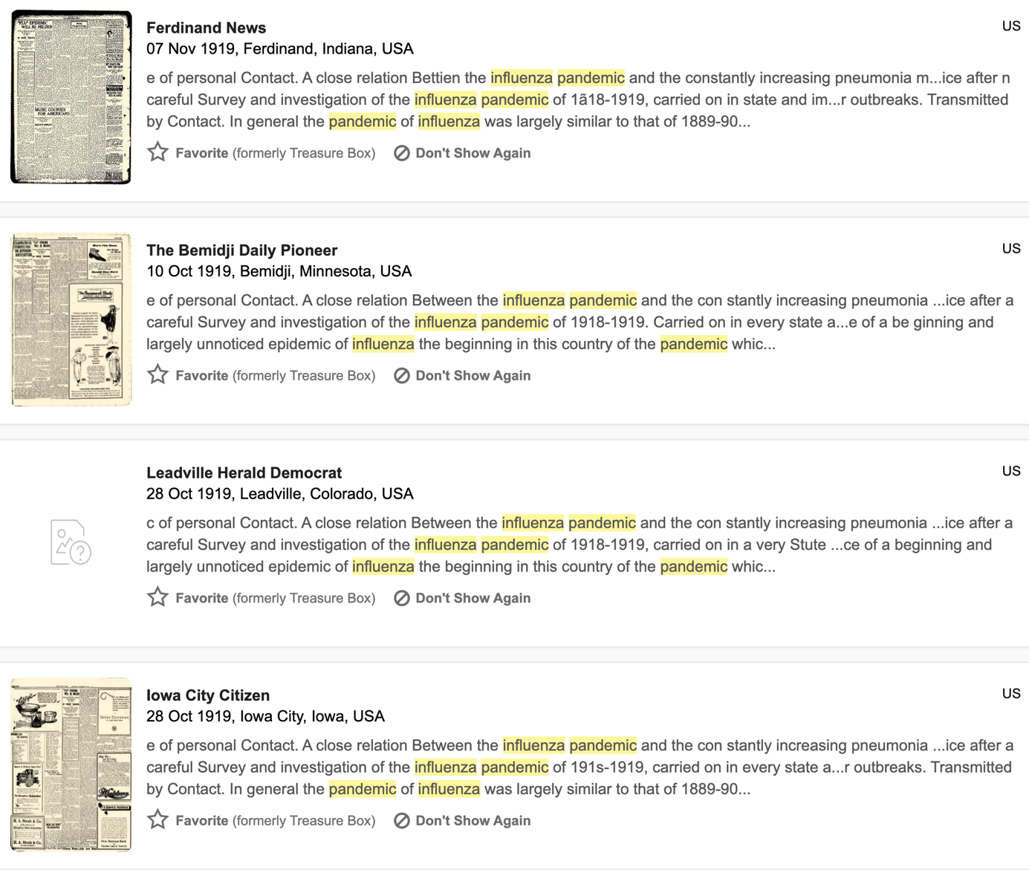
Another telling fact: these “pandemic” articles were never big front-page stories—they were buried next to church news and the latest sales of eyeglasses.
According to a 1920 Harvard historical document, 5000 people in Boston died from the Pandemic of 1918, and the same article reported that Boston was the third largest city death count in America.[3] This fact also leads one to again question the death count of 500,000 in the US. It also explains the curious fact that no one in my family mentioned this purportedly horrific disease event. My grandparents and great uncles and aunts, who were alive and working in 1918, never discussed a pandemic or even any big disease outbreak. My grandfather was a barnyard musician and great story teller who told me family tales about everything-- Great Aunt Delia falling into the cistern, the problems of using a clevis pin in 20 below zero weather to hook the T-bar to the horse drawn wagon--but not one peep about the Great Pandemic of 1918. Although it would have occurred in the prime of his young adulthood, the “Great Pandemic” apparently was not a major event in his life. In his diary which he faithfully kept daily from 1893 to 1963 there is one entry in 1918 that some relative “got the flu”. No further mention of death or disability—and he faithfully recorded these events over the years. My father was 13 years old at the time of the pandemic. He discussed with me that he had osteomyelitis -- an infection of his tibia that resulted in his being bedridden for months when he was around 10 years old. This should have focused his attention on the issue of disease and recovery. But he never mentioned “the pandemic”. As an adult, he earned his MD, DDS and a PhD in biochemistry, taught Dentistry at Harvard, did research, practiced medicine, and was generally a student of 20th century history—but a “pandemic” was not on his radar. I recently spoke to a group of about 350 people, and simply asked anyone to tell me afterward if they had ever heard family talk about the loss of members in the “Pandemic” of 1918. Only one person told me that her family passed down a story, but when she investigated it, the person had actually died years before the outbreak.
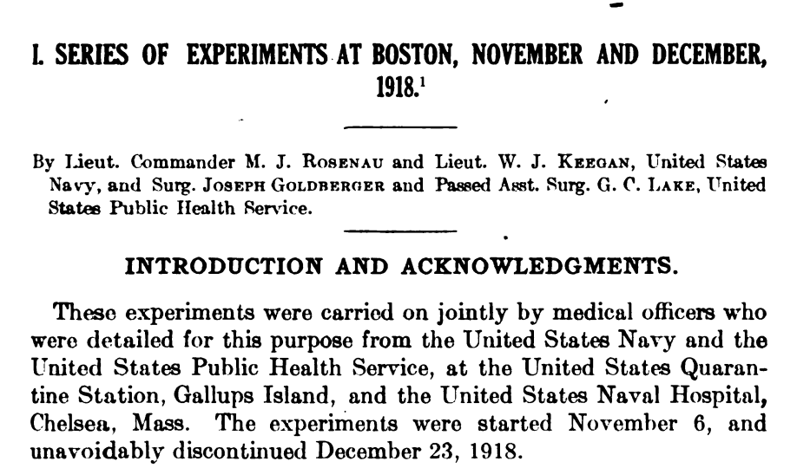
Why the pandemic was called the Spanish flu is unclear. The disease did not start in Spain, but rather, around Fort Riley Kansas which was a training base for the First World War. Army recruits at the base were becoming ill, and many were dying of a strange pulmonic disorder associated with fever, severe fatigue, and bloody discharge. We have numerous sources of direct history of the event—memory books that were written by families, the diary and later books of Dr. Eleanora McBean who volunteered with her family to provide care to the recruits, the autopsy results of Colonel William Welch and pathologists from the Armed Forces Institute of Pathology, pharmaceutical history, Kansas historical Archives, Nany and Public Health Service Archives, and numerous other eyewitness accounts. Unlike today, the US Public Health Service made an honest attempt to understand transmission of the illness. They enlisted volunteers who leaned over the dying without touching them, putting their mouths close to the mouths of the sick, and breathing in their exhalations. The volunteers did not become ill. Then, they had sick and dying people cough on the volunteers. They swabbed mucus and nasal secretions from the sick and stuffed it into the noses and throats of the well. In the days before antibiotics, they even spun down the secretions of the dying and injected this solution into the well volunteers. But no matter what they did, they could not transfer this new disease to the healthy volunteers. In actual numbers, zero out of 118 well volunteers became sick. From the Navy Archives, “The volunteers were repeatedly exposed to hospital patients exhibiting influenza-like symptoms in an attempt to make them contract the disease. Although the 118 men failed to develop influenza, they all received full pardons in recognition of their participation.^{”[4]} (This tells you the “volunteers” were actually not so voluntary—probably being in the brig at the time.)
Curiously, horses were also affected with this respiratory disease, so they tried to prove transmission in horses. They moved feed bags from the snout of a sick horse to a healthy horse. No healthy horse became sick. They tried to find a bacillus that accounted for the disease but could not find bacilli that were not also found in the well. In spite of all this, at the end of time, they just could not give up the notion of person-to-person transmission, (or like today they were being incentivized and/or coerced by the pharmaceutical companies). The reluctant conclusion of the Public Health Service researchers at the time was this (reproduced with the original bold and capitalized emphasis):
“The results of these experiments indicate PRESUMPTIVELY that influenza MAY be transmitted by means of the secretions of the upper respiratory passages from patients in the early stages of this disease, probably within less than 12 hours from onset. VERY DEFINITE CONCLUSIONS CAN NOT BE DRAWN…These conclusions, however, contradict the specific results of each of the three series of experiments reported within the document, where we find that NONE of the volunteer soldiers exposed to the fluids of patients with symptoms of Spanish Flu contracted the Spanish Flu symptoms.”[5]
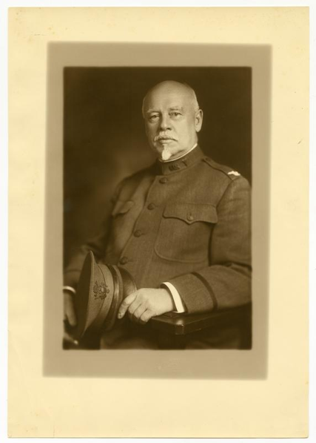
Dr. William Welch and a team of AFIP Pathologists, bravely undertook to autopsy the dead. (This should be the first line of inquiry in any new “disease” but was actually prohibited by the medical authorities in the age of COVID.). Caretakers of the dying, in 1918, had observed that young men would develop fever and cough, then suddenly would cough up blood and die. The autopsies of the troops revealed that many of them had lungs filled with blood. Some were “consolidated” or edematous and bacteria were consistently found. But the pathologists could not understand how “bacterial pneumonia” would act so differently in 1918 than any previous encounters. A review was done 100 years later by researcher Zon-Mei Sheng et al., who reviewed paraffin tissue blocks from Army personnel who had died of the disease. “All 68 cases had histological evidence of bacterial pneumonia, and 94% showed abundant bacteria on Gram stain.”

They then go on to use modern genetic analysis (feel free to skip to the punchline):
“Sequence analysis of the viral hemagglutinin receptor-binding domain performed on RNA from 13 cases suggested a trend from a more “avian-like” viral receptor specificity with G222 in pre-pandemic cases to a more “human-like” specificity associated with D222 in pandemic peak cases. Viral antigen distribution in the respiratory tree, however, was not apparently different between pre-pandemic and pandemic peak cases, or between infections with viruses bearing different receptor-binding polymorphisms. The 1918 pandemic virus was circulating for at least 4 mo. in the United States before it was recognized epidemiologically in September 1918. The causes of the unusually high mortality in the 1918 pandemic were not explained by the pathological and virological parameters examined.” [6]
Obviously, they wanted to find viral cause but instead found bacteria and no consistent viral pattern. So, what was going on in 1918?
As a bit of medical history not taught to modern medical students, influenza did not exist as a yearly disease until around the 1850’s, after the first telegraph lines were strung. The diagnosis “neurasthenia” was coined in 1867 to describe an illness of nervousness, listlessness, palpitations, depression and sometimes focal paralysis. It was noticed that the disorder clustered around telegraph line installers, switch board operators, and railroad workers (telegram lines were strung along the rail lines) and thus neurasthenia became known as Telegrapher’s Disease.
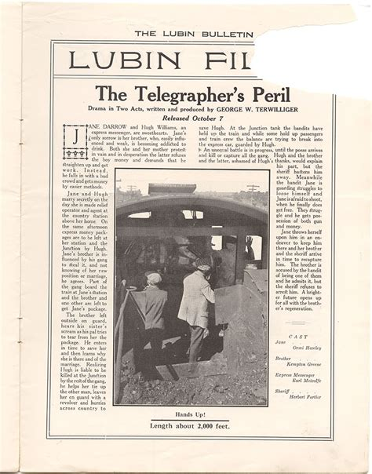
In fact, in 1907, the Bell Telephone switchboard operators in Toronto went on strike for better working conditions. This was documented in a Royal Commission study in Canada, headed by a former Prime Minister. And “Telegrapher’s Paralysis” was reported by a physician in France.[7] And the punch line? In Oct 1917, at the request of the U.S. Army Signal Corps, K.S.A.C. instituted a course in wireless telegraphy. [8] The Army Recruits at Ft. Riley, Kansas were training to be Telegraph operators for WWI.
Before you think that electromagnetic exposure is too far-fetched as an explanation, it was discovered that making a long twist in the copper wire for the telegram lines lessened the symptoms of the neurasthenia experienced by people working under the lines. And the really convincing bit of evidence came from the unexpected realm of astronomy. In the 1970s, an astronomer R.E Hope-Simpson, and a mathematician from the University of Wales by the name of F. Hoyle demonstrated that influenza outbreaks occurred nearly simultaneously around the world in association with increased solar activity-- sunspots flares, etc.[9]

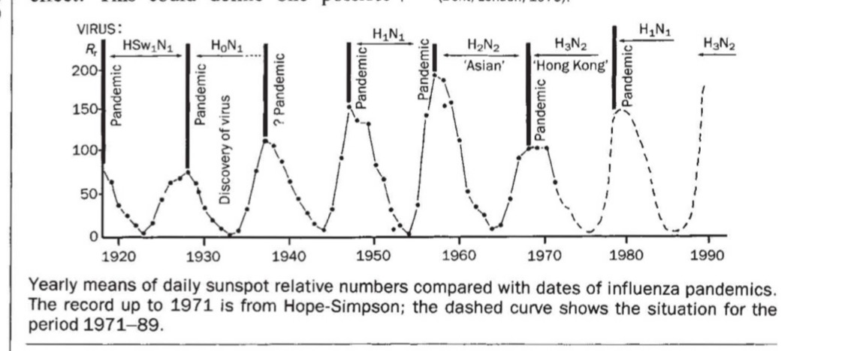

Ken Tapping,-- a Canadian Astronomer in 2001 also made the observation that in years 1700 to 1979, including 150 years prior to the era of Telegraphy, Influenza outbreaks occurred one to three decades apart, and coincide perfectly with peaks of solar magnetic activity. As documented in Dr. Arthur Furstenberg’s book The Invisible Rainbow an infectious agent does not account for near simultaneous transmission of disease around the globe in an age before air transport[10]. Reports based on ships logs reveal that, in the age of “wooden ships and iron men”, the disease would simultaneously sweep over multiple ships widely dispersed at sea—ships that had not had contact with land or with other ships for prolonged periods. And as a 2016 article by Qu and Gao et al. “Sunspot Activity, Influenza and Ebola Outbreak Connection” points out, influenza may not be the only disease where our ideas of transmission may be wrong.[11] (Consider this when the issue of 5G and Covid keeps resurfacing.)

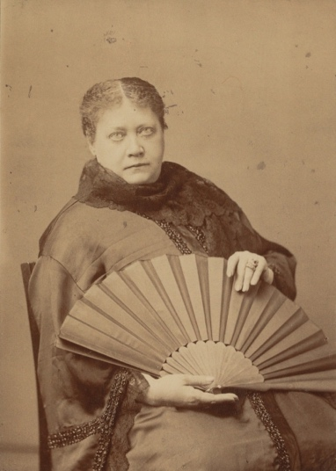
Interestingly, Madame Helena Blavatsky the famous (or notorious as some would note) Theosophist wrote: “Does it not seem therefore, as if the causes that produced influenza were rather cosmical than bacterial; and that they ought to be searched for rather in those abnormal changes in our atmosphere.”. And even more presciently, during an influenza outbreak of 1890: “The influenza thou has already in thy pocket, for people see it peeping out. Of people daily killed in the streets of London by tumbling over the electric wires of the new
Lighting craze we already a premonition through news from America.”
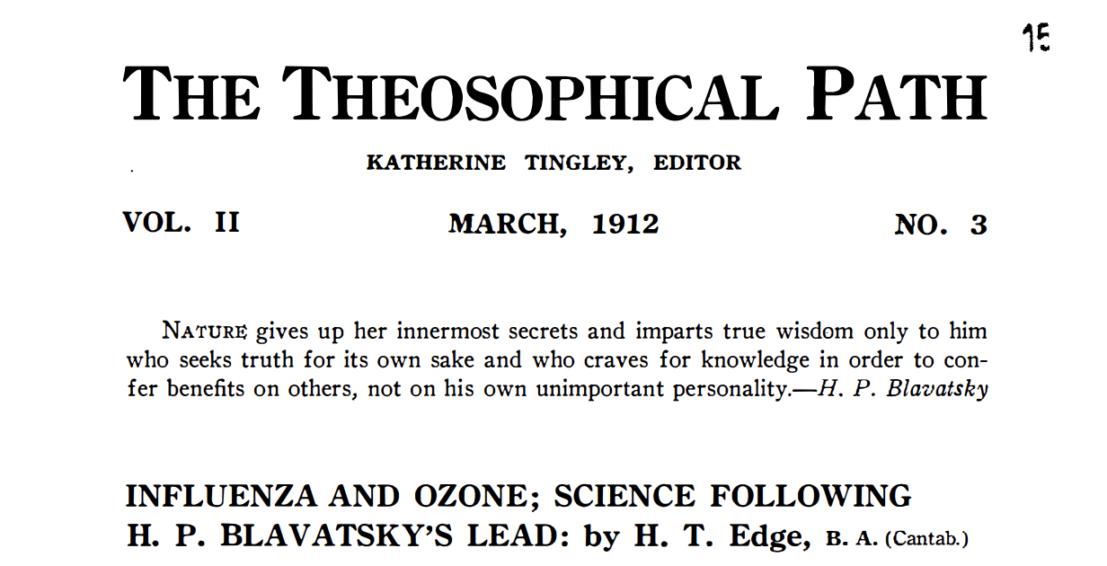

The biology/physiology of this effect is at least partly understood. Metabolism depends on an electron transfer chain within the mitochondria—intracellular organelles which take the results of metabolism and convert it energy within each living cell. The flow of electrons can be altered with the application of a sudden electromagnetic field. Additionally, the rate at which the EMF is introduced matters. In medicine, we once were taught “Cannon’s Law of the Body” that the body responds to rate of change not just absolutes. We are physiologically better able to adapt to a new environment if it is applied slowly. So, in the 1918 Ft. Riley outbreak, some recruits—not previously exposed to electricity-- were suddenly surrounded by miles of copper wire transmitting signals that were typed out at discordant 7.2 Hz frequency, just shy of the natural Schumann earth resonance of 7.83 Hz. It was observed by doctors stationed at the army camps during the autumn 1918 wave of influenza, that those young men who were dying, more often than not, big, were the big brawny country boys, not the pale, scrawny city boys. This makes sense when you consider that the city kids had already been slowly adapted to the electrification of their cities. [12]
Prior to 1900, medical studies of Telegrapher’s disease and Neurasthenia actually showed that people may have had a miserable anxiety ridden existence, but it did not shorten their life span—in fact life span may have been slightly extended. So, what accounted for the sudden mass death in the camp? There were at least two other factors contributing to the Pandemic death count that are very reminiscent of COVID deaths today.
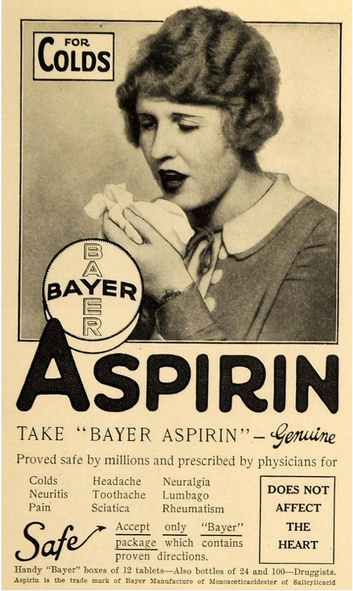
In 1918, The Bayer Company, a subsidiary of IG Farben, had just lost their patent on Aspirin, a drug that German scientists accidentally discovered lowered fever. So, the company waged a PR campaign to convince doctors via the AMA and the newly organized medical education establishment that lowering temperature with Aspirin, was a great idea for recovery from disease! Today, we have considerable data from India on the treatment of Tuberculosis and Polio, that fever is beneficial to resolving disease. Lowering temperature by chemical means extended the active phase of disease and resulted in more paralysis and increased mortality. But that information was not available in 1918, (and still ignored by most physicians today).
Nor did physicians of 1918 understand the risk of bleeding with higher dosing of Aspirin. Diarists of the pandemic report seeing doctors giving handfuls of aspirin to reduce the fever in recruits. And, in confirmation, it was noted by physicians in 1918 that as the disease progressed, victims began bleeding from the nose, and mouth. Many deaths subsequently occurred with hemorrhagic lungs—lungs filled with blood, not pus.
Finally, and probably the most damaging, yet debated, factor was this: WWI was the first conflict in which our military were given multiple (and experimental) vaccines.
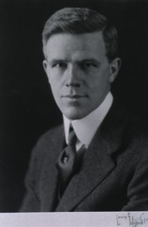
Dr. Frederick L. Gates was from not one but multiple Ivy League Schools, beginning at the U. of Chicago and transferring to Yale where he was awarded the Andrew D. White award.(White was a member of the Order of Skull and Bones). Gates subsequently graduated with honors from Johns Hopkins Medical School in 1913, and in 1917 when America entered the war, volunteered for the Army Medical Corps. He was commissioned as a First Lieutenant. Surprisingly, for a newly minted medical officer, Gates was assigned to duty on the Rockefeller Institute staff, likely due to his father Frederick Taylor Gates being a personal assistant to John D. Rockefeller.
Gates the elder is credited with Rockefeller’s getting involved in organized medicine. “ Although Rockefeller himself believed in folk medicine, the billionaire listened to his experts, and Gates convinced him that he could have the greatest impact by modernizing medicine especially by reforming education, sponsoring research to identify cures, and systematically eradicating debilitating diseases that sapped national efficiency like hookworm…In 1901, Gates Senior designed the Rockefeller Institute for Medical Research (now Rockefeller University), of which he was board president. He then designed the Rockefeller Foundation, becoming a trustee upon its creation in 1913.” [13]
According to his memorial biography, Dr. Frederick L. Gates “gave lectures to military groups (at the Rockefeller Institute) … was also assigned to visit training camps, in the interest of preventive medicine, and traveled widely”. What they don’t mention is his role as primary investigator on the vaccinations given at Ft. Riley, Kansas prior to the outbreak of disease.
On May 25, 1917 an Army Medical School had been established at Ft. Riley, Kansas. Shortly thereafter, in October 1917, 525 cases of Typhoid Fever occurred in Kansas, and the State Board of Health gave 9,000 “free shots”.[14] Three months later, an outbreak of “meningitis” occurred. The US Navy and Army estimated that 40 percent and 36 percent of their servicemen had been affected.[15] (It is important to note that an “outbreak” of meningitis usually involves one or two people. The largest outbreaks in the last 50 years I could identify were groups of gay men in San Francisco and LA with 20-30 cases. To have over 30% of personnel affected is totally outside the norm for reported outbreaks of meningitis.) The response again was to administer more crude home-made meningitis vaccines, beginning in January 1918 and continuing into February 1918.

From the Kansas historical society records:
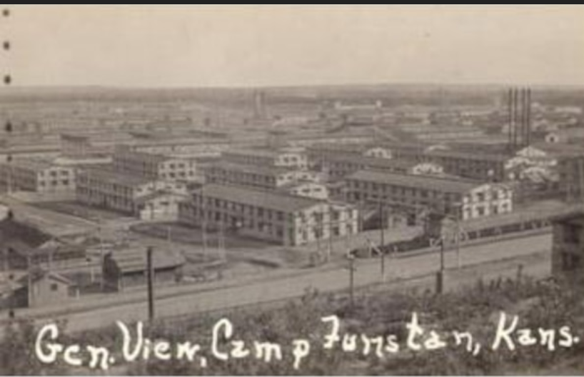
“Following an outbreak of epidemic meningitis at Camp Funston, Kansas, in October and November, 1917, a series of anti-meningitis vaccinations was undertaken on volunteer subjects from the camp. Major E. H. Schorer, Chief of the Laboratory Section at the adjacent Base Hospital at Fort Riley, offered every facility at his command and cooperated in the laboratory work connected with the vaccinations… In the camp, under the direction of the Division Surgeon, Lieutenant Colonel J. L. Shepard, a preliminary series of vaccinations on a relatively small number of volunteers served to determine the appropriate doses and the resultant local and general reactions. Following this series, the vaccine was offered by the Division Surgeon to the camp at large, and "given by the regimental surgeons to all who wished to take it.”

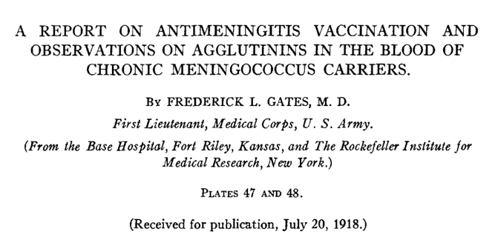
This excerpt from Dr. Gates’ paper on the research submitted for publication in 1918 gives you a flavor of the state of vaccination art and his involvement at that time:
“The vaccine used was made in the laboratory of The Rockefeller Institute. 16-hour growths on 1 per cent glucose agar in Blake bottles were washed off with isotonic salt solution, like strains pooled, and the concentrated suspensions immediately heated to 65°C. for 30 minutes to kill the cocci and inactivate the autolytic ferment…Accordingly, the vaccinations were begun with the injection of 500 million cocci, and this initial dose was increased in successive groups by 250 or 500 million until it had reached 2,000 million. For the second and third doses in each group, the first dose was usually multiplied by two and by four…About half of those vaccinated, whose third injection was due after February 4, 1918, were given a final injection of 4,000 million, on account of the occurrence of several fairly severe reactions from the larger dose among medical officers at Fort Riley. In some regiments the vaccinations had been completed before February 5."[16]

At the same time Kansas military bases were being vaccinated, schools were, for the first time, seriously mandating vaccines for attendance in Kansas. From the Lawrence Daily Journal World, 3 Jan. 1918: [17]

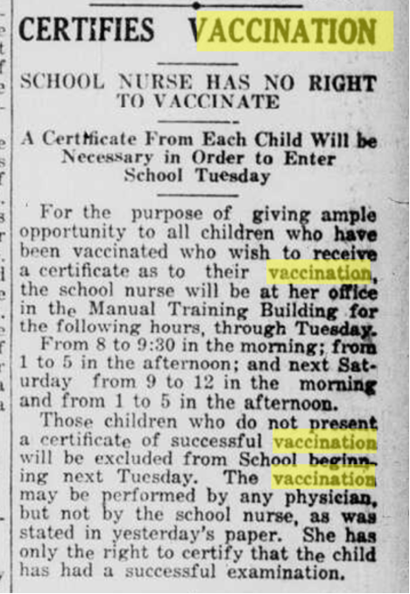

A summary of the time course of the 1918 Pandemic
May 25, 1917, an Army Medical School had been established at Ft. Riley, Kansas.
October, 1917, 525 cases of Typhoid Fever occurred in Kansas and the State Board of Health gives 9,000 “free shots” in response to 525 cases of Typhoid Fever in Kansas.
October and November, 1917, Meningitis breaks out and a second round of vaccines—this time for Meningitis was given.
In January and February of 2018, Military recruits, and school children, , were required to have a variety of crude vaccines partially concocted at the time of inoculation. Although I cannot prove this in the news, it is likely that—as is true today—the Indian Health Service pushed vaccination on the Native Americans.
One month later, in March of 1918, Scarlet Fever epidemics were reported from Cowley, Butler, Dickinson and Leavenworth counties.
Also in March 1918, five students at the (Native American) Haskell Institute 95 miles from Ft. Riley had died and 457 were ill with a disease called “strep-grip.”
In September 1918, the disease still was not front-page news. Throughout this time, there were more concerns over wheat shortages, Anti-German discrimination, and conscientious objectors to the war. The Kansas City Star reported that Mrs. James Farrell, Effingham, was the knitting champion of Atchison County. She had knitted 100 pairs of socks for the Red Cross since August, 1917.
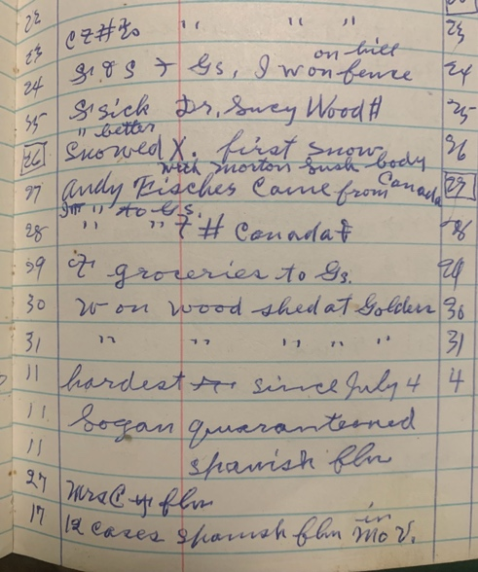
In October, 1918, three hundred cases of what was now being called “Influenza” was being reported in the state. Hays was hardest hit with 200 cases yet still reported only several deaths. By the middle of October, 1918, Kansas Governor Capper issued a state-wide closing order, effective for one week, in an effort to halt the flu epidemic. Over 7,000 cases had been reported statewide. Even accounting for underreporting this does not suggest a pandemic of epic proportion. Also on October 25, 1918, my grandfather recorded in his diary that relatives arrived from Canada and a few days later the town of 1200 people was put on quarantine.
2 November, 1918, The State Board of Health in Kansas lifted the influenza closing order.
This graph shows the very acute time course of influenza deaths in 1918, beginning about 6 months after the vaccinations took place, and going away three months later—never to return.
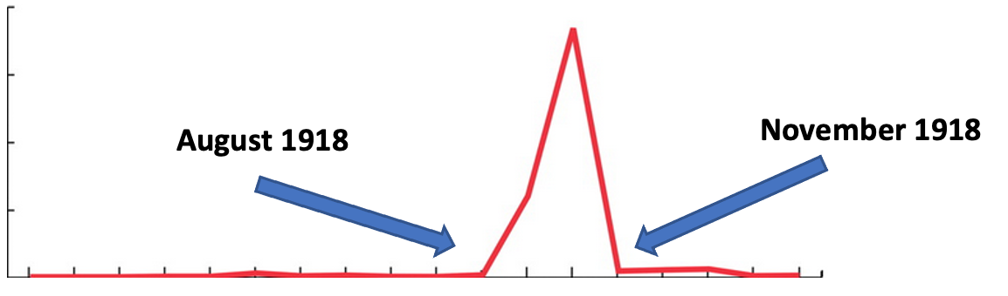From: Sheng, ZM, Chertow, DS, Ambroggio, X et al,
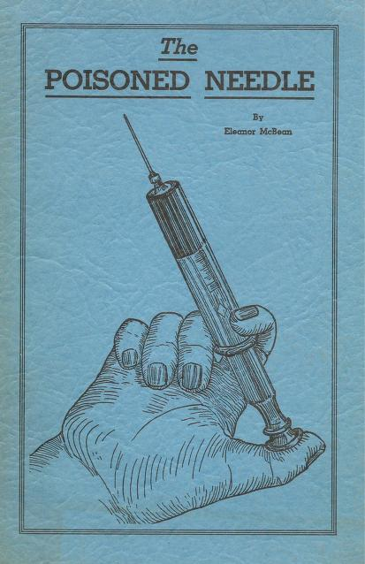
Although we have seasonal illness we call Influenza, and occasionally Influenza breaks out worldwide as it has done for centuries, never since 1918 have we seen this unusually lethal type of outbreak until 2019 and the COVID “Pandemic”. What is discounted, forgotten, or purposely ignored are the observations of Dr. Eleanora McBean who actually witnessed the outbreak at Ft. Riley, Kansas, and as a child helped her family care for sick soldiers and community members. Writing later, as a physician, she reported that the only deaths were in the vaccinated. Her family was exposed to diseased people daily, along with others who volunteered to care for the sick. They were unvaccinated and as people were dying around them, according to Dr. McBean they “didn’t even get the sniffles”.
Most of the historical search for this article focused on Kansas because it is generally cited as ground zero for the “Great Pandemic”. Looking about America, the disease disproportionately hit cities, and concentrations of military or other people living together in dormitories or Indian Reservations. These people were mandated to have vaccines, or were likely to have been told by their local authorities to do so. Neither the numbers cited by any individual city or locale, nor by the counties seem to add to the gross numbers we hear today. It is apparent that in a few places, an unusual number of folks became unusually ill. These places—such as Fort Riley and Boston generated a mythos that was remembered by the medical establishment more than the public at large.
People who developed neurasthenia, in the absence of vaccination, could become symptomatic, but did not develop the severe pulmonary symptoms and were found in some studies to live longer than average. But propaganda seems to have been deployed consciously via the newspapers from 1920 to today regarding the causes of the disease of 1918.
Looking at the totality of the evidence, the Pandemic of 1918 was not probably a communicable disease, but a disease of communicable technologies. Americans went to Europe and we took our Telegram equipment and vaccines with us for sale on the European market. When the soldiers were returning home, the public was convinced through aggressive marketing campaigns to get vaccinated because the troops were returning from Europe with “Disease”. The vaccine timing explains the huge spike of disease and death during a narrow time range following a rapid multiple vaccination rollout. The later prolonged, less dramatic occurrences of death followed a more sluggish civilian adoption of the vaccine program.
The Pandemic of 1918 as the prototype of infectious transmissible worldwide disease is based on skewed history, propaganda, and assumptions, not proof. This underscores the need today for true systematic scientific inquiry where we examine the basics and the basis of our views of biology and disease--not just an “Epidemiologic” mapping of sick people, coupled with preconceived notions. In fact, it is difficult not to wonder about the role of the Rockefeller Institute under Gates Senior orchestrating this whole show. Given the physicians and scientists who have unexpectedly died in the 20th century, such as famous cancer researcher Dr. Mary Sherman of SV-40 fame, it is worth mention that Dr. Frederick Gates, after the war, and after his father was deceased, moved to Harvard where he died young from a blow to the head. In less polite circles that might be suspected as “cutting the trail”.

[1] C.C. Wang, Prather, K.A., Sznitman, J., et al, Airborne Transmission of Respiratory Viruses, Science Vol 373 no 6558.
[2] https://www.cdc.gov/flu/pandemic-resources/1918-commemoration/1918-pandemic-history.htm
[3] https://info.primarycare.hms.harvard.edu/review/1918-influenza-and-covid19
[4] https://www.history.navy.mil/research/library/online-reading-room/title-list-alphabetically/i/influenza/a-forgotten-enemy-phss-public-health-service-fight-against-the-1918-influenza-pandemic.html
[5] Experiments upon volunteers to Determine the Cause and Mode of Spread of Influenza (aka “Spanish flu”. Hygienic Laboratory—Bulletin No. 123 Feb, 1921 Treasury Department, US Public Health Service. Page 172-272

[6] Sheng, ZM, Chertow, DS, Ambroggio, X et al: Autopsy series of 68 cases dying before and during the 1918 influenza pandemic peak, PNAS September 19, 2011, 108 (39) 16416-16421 https://doi.org/10.1073/pnas.1111179108
[7] London: The Graphic, April 1875
[8] https://ksww1.ku.edu/special-projects/100-years-ago-in-kansas/
[9] Qu J, Gao Z, Zhang Y, Wainwright M, Wickramasinghe NC, et al. (2016) Sunspot Activity, Influenza and Ebola Outbreak Connection. Astrobiol Outreach 4: 154. doi:10.4172/2332-2519.100015
[10] Firstenberg, Arthur, The Invisible Rainbow, Chelsea Green Publishing, London US 2020. p 75-93
[11] Qu J, Gao Z, Zhang Y, Wainwright M, Wickramasinghe NC, et al. (2016) Sunspot Activity, Influenza and Ebola Outbreak Connection. Astrobiol Outreach 4: 154. doi:10.4172/2332-2519.100015
[12] Pettit, DA America Experiences Pandemic Influenza, A Cruel Wind, 1918-1920 A SOCIAL HISTORY. Thesis, Winter 1976, du/cgi/viewcontent.cgi?article=2144&context=dissertation
[13] https://en.wikipedia.org/wiki/Frederick_Taylor_Gates
[14] https://ksww1.ku.edu/special-projects/100-years-ago-in-kansas/
[15] https://www.nationalww2museum.org/war/articles/medical-innovations-1918-flu
[16] https://rupress.org/jem/article-pdf/28/4/449/1175015/449.pdf

